Math 338

**Lab Assignment #1**

Fall 2019

This is an intentionally short lab to get you familiar with the basics of importing data into R and Rguroo.

Go to [https://www.rguroo.com](https://www.rguroo.com/), click Register, then click Student and register for an Rguroo account using your student e-mail address(your_login@csu.fullerton.edu). If you use your student e-mail address you will not have to pay for Rguroo access. Then, go into your student e-mail and complete the registration process.

Once you have registered for an Rguroo account, introduce yourself to **six** other students in the class. Ask them to tell you:

* Their name
* Their major
* Their height in inches
* Their favorite color
* Approximately how far away from campus they live
* How many units they are taking this semester

Record your responses in an Excel or Google Sheets spreadsheet. Follow the principles of tidy data: put each student in its own row, each variable in its own column, and each value in its own cell.

Save/export the file with a **.csv** extension. Then, go to the *Data* section of Rguroo and select *Data Import → Data Frame*. Click on *Browse* and find the file on your desktop. Leave all other options as is for now, except maybe check the *Strip Blanks* box to make sure nothing weird is going on. If you do not like the default name, type a name in the *Name* section. Click on *Upload*, and upon doing so the file will appear under the *Datasets* window on the left, and a table will appear in the middle of the interface, displaying the *Summary* of the dataset.

**Question #1** Paste below a screenshot of the Summary table that automatically appears when a dataset is uploaded to Rguroo.

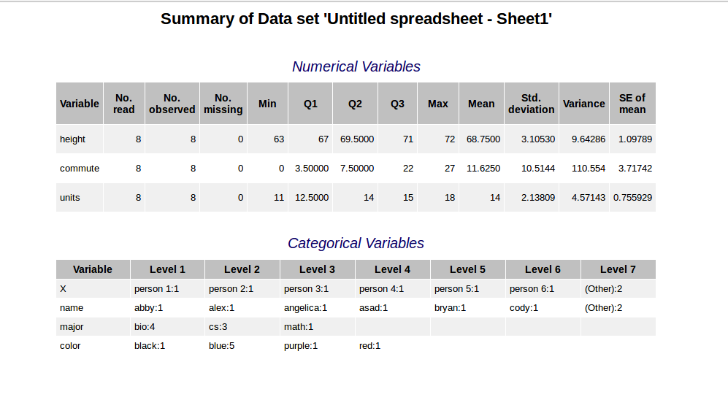

Next, open R Studio on a lab computer (or on your computer if you have it already installed). In the top right pane, under *Environment*, click *Import Dataset → From Text (readr)*. Again, browse to find the file, and if you do not like the default name, type a name in the *Name* section. Once done, click *Import* to import the same file into R. Once the file is imported, you should see it in the Environment window.

Click *File → New File → R Script* (or press *Ctrl + Shift + N*) to open up a new script in the top left. In the script window, type:

**summary(dataset)**

**# you should replace dataset with the actual name of the dataset in the Environment window**

**# comments are indicated with the # symbol – you don’t actually have to type these commented lines**

Next, put your cursor on that line (or highlight the code) and click *Run* (or press *Ctrl + Enter*). In the Console window in the bottom right, you should now see:

**> summary(dataset)**

followed by the output of the command.

**Question #2** Paste below the summary output from R.

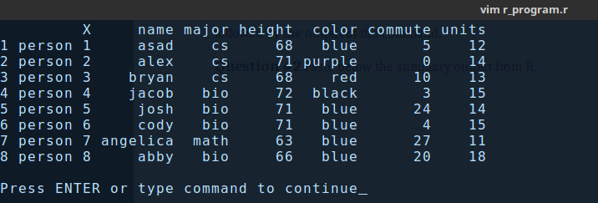

**Question #3** What differences (if any) do you see between the default *Rguroo* summary and the default *R* summary?

One is represented via Rguroo is similar to the original Excel spreadsheet which is more graphical. The text based version directly reads the CSV file and outputs it to a row column format in text.